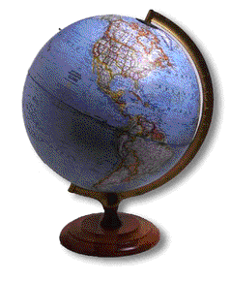
Natural Resources

Environment v. Economy

- Global Carbon Dioxide Emissions

Biomes

- Definition of Biome
- Terrestrial Biomes Comparison
- Biomes of the World
- Location of Biomes in North America
- Tropical Rainforests Fact Sheet
- Deserts Fact Sheet

Resource Profiles

- Elements of Survival
- Quality of Life Revisited
- Framing the Issue: Resource Profiles

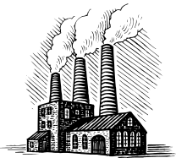
Global Carbon Dioxide Emissions

The statistics below is a ranking of the world's countries by 2002 total CO2 emissions from fossil-fuel burning, cement production, and gas flaring. Emissions (CO2_TOT) are expressed in thousand metric tons of carbon (not CO2). National per capita estimates (CO2_CAP) are expressed in metric tons of carbon.

- On an outline map of the world, draw located proportional circles representing the total carbon dioxide emissions from the 20 largest emitters. Be sure to add all of the usual map essentials! Describe the distribution plotted on the map, and your conclusions, in writing. Make special note of any relationship you see between carbon dioxide emissions and the development process.

- Re-rank these top 20 emitter nations by the national per capita estimates of carbon dioxide emissions. On your map of the world, draw located proportional people representing the national per capita estimates of carbon dioxide emissions. Add to your written analysis by describing the relationship you see between the size of per capita carbon dioxide emitters and the development process.

RANK NATION CO2_TOT CO2_CAP

1 UNITED STATES OF AMERICA 1592382 5.52
2 CHINA (MAINLAND) 957249 0.74
3 RUSSIAN FEDERATION 390439 2.69
4 INDIA 332677 0.32
5 JAPAN 327939 2.57
6 GERMANY 219270 2.66
7 UNITED KINGDOM 148129 2.50
8 CANADA 140915 4.49
9 REPUBLIC OF KOREA 121578 2.55
10 ITALY (INCLUDING SAN MARINO) 117989 2.05
11 MEXICO 104543 1.01
12 FRANCE (INCLUDING MONACO) 100358 1.69
13 ISLAMIC REPUBLIC OF IRAN 98153 1.50
14 AUSTRALIA 97096 4.94
15 SOUTH AFRICA 94110 2.07
16 SAUDI ARABIA 92794 4.22
17 BRAZIL 85492 0.49
18 UKRAINE 83599 1.73
19 INDONESIA 83513 0.39
20 SPAIN 82998 2.03

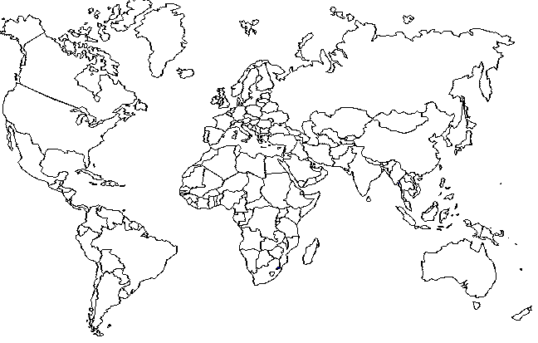
RANK NATION CO2_TOT CO2_CAP

21 POLAND 80762 2.09
22 THAILAND 63195 1.00
23 TAIWAN 62014 2.87
24 TURKEY 56675 0.81
25 MALAYSIA 41316 1.72
26 NETHERLANDS 41111 2.55
27 KAZAKHSTAN 40305 2.71
28 EGYPT 39155 0.59
29 DEMOCRATIC PEOPLE'S REPUBLIC OF KOREA 39023 1.73
30 ARGENTINA 36328 0.96
31 UZBEKISTAN 33332 1.31
32 CZECH REPUBLIC 31216 3.06
33 PAKISTAN 29612 0.20
34 VENEZUELA 29472 1.17
35 UNITED ARAB EMIRATES 25657 8.74
36 GREECE 25645 2.33
37 ALGERIA 25095 0.80
38 BELGIUM 24980 2.42
39 ROMANIA 23636 1.08
40 IRAQ 21654 0.90
41 PHILIPPINES 20103 0.25
42 ISRAEL 18966 2.89
43 VIET NAM 18069 0.23
44 AUSTRIA 17357 2.16
45 NORWAY 17216 3.79
46 FINLAND 17073 3.28
47 PORTUGAL 16972 1.64
48 BELARUS 16338 1.65
49 KUWAIT 16316 7.21
50 SINGAPORE 15643 3.52
51 COLOMBIA 15634 0.36
52 CHILE 15619 1.00
53 HUNGARY 15435 1.52
54 NIGERIA 14179 0.12
55 SWEDEN 14142 1.59
56 LIBYAN ARAB JAMAHIRIYAH 13738 2.51
57 SYRIAN ARAB REPUBLIC 13378 0.78
58 DENMARK 12976 2.42
59 FEDERAL REPUBLIC OF YUGOSLAVIA 12708 1.16
60 MOROCCO 11897 0.40
61 IRELAND 11768 3.00
62 TURKMENISTAN 11481 2.39
63 BULGARIA 11423 1.45
64 TRINIDAD AND TOBAGO 11231 8.80
65 SWITZERLAND 11132 1.51
66 SLOVAKIA 10038 1.87
67 QATAR 9932 16.53
68 HONG KONG 9656 1.42
69 BANGLADESH 9412 0.07
70 NEW ZEALAND 9255 2.37
71 OMAN 8207 3.02
72 AZERBAIJAN 7629 0.94
73 PERU 6945 0.26
74 ECUADOR 6767 0.53
75 CUBA 6435 0.57
76 TUNISIA 6013 0.61
77 DOMINICAN REPUBLIC 5870 0.68
78 BAHRAIN 5811 8.65
79 CROATIA 5754 1.30
80 BOSNIA-HERZEGOVINIA 5076 1.33
81 JORDAN 4558 0.86
82 LEBANON 4467 1.24
83 ESTONIA 4344 3.20
84 SLOVENIA 4172 2.09
85 PUERTO RICO 3705 0.96
86 YEMEN 3539 0.18
87 LITHUANIA 3424 0.99
88 ZIMBABWE 3393 0.26
89 JAMAICA 2945 1.12
90 SRI LANKA 2823 0.15
91 GUATEMALA 2807 0.23
92 MACEDONIA 2795 1.37
93 U.S. VIRGIN ISLANDS 2795 25.41
94 BOLIVIA 2745 0.32
95 LUXEMBOURG 2573 5.79
96 SUDAN 2388 0.07
97 MONGOLIA 2260 0.91
98 ANGOLA 2101 0.16
99 MYANMAR 2079 0.04
100 GHANA 2047 0.10
101 KENYA 1965 0.06
102 REPUBLIC OF MOLDOVA 1835 0.41
103 CYPRUS 1818 2.56
104 COTE D'IVOIRE 1749 0.11
105 LATVIA 1718 0.73
106 PANAMA 1704 0.56
107 EL SALVADOR 1698 0.26
108 ETHIOPIA 1688 .
109 BRUNEI (DARUSSALAM) 1685 4.94
110 HONDURAS 1621 0.24
111 COSTA RICA 1590 0.40
112 KYRGYZSTAN 1351 0.27
113 NETHERLAND ANTILLES 1345 6.14
114 TAJIKISTAN 1281 0.20
115 SENEGAL 1139 0.11
116 PARAGUAY 1123 0.20
117 BOTSWANA 1117 0.63
118 GUAM 1116 6.93
119 URUGUAY 1112 0.33
120 NICARAGUA 1054 0.20
121 NEPAL 1048 0.04
122 UNITED REPUBLIC OF TANZANIA 976 0.03
123 REPUBLIC OF CAMEROON 944 0.06
124 GABON 943 0.76
125 GEORGIA 901 0.17
126 MAURITIUS 848 0.70
127 MAURITANIA 844 0.30
128 MALTA 806 2.04
129 ARMENIA 803 0.24
130 ALBANIA 705 0.22
131 PAPUA NEW GUINEA 676 0.12
132 REUNION 673 0.90
133 CONGO 639 0.18
134 MADAGASCAR 629 0.03
135 SURINAME 614 1.42
136 MARTINIQUE 612 1.57
137 ICELAND 604 2.10
138 NAMIBIA 586 0.30
139 BAHAMAS 568 1.83
140 ZAMBIA 558 0.05
141 ARUBA 541 5.75
142 BENIN 524 0.08
143 NEW CALEDONIA 497 2.29
144 MACAU 493 1.14
145 ZAIRE 486 0.01
146 HAITI 482 0.06
147 TOGO 472 0.10
148 GUADELOUPE 469 1.07
149 UGANDA 451 0.02
150 GUYANA 439 0.57
151 MOZAMBIQUE 409 0.02
152 FIJI 369 0.44
153 GUINEA 357 0.04
154 LAO PEOPLE'S DEMOCRATIC REPUBLIC 350 0.06
155 BARBADOS 333 1.24
156 NIGER 331 0.03
157 BURKINA FASO 297 0.02
158 MALDIVES 281 1.00
159 FRENCH GUIANA 270 1.54
160 SWAZILAND 264 0.25
161 BELIZE 215 0.81
162 MALAWI 214 0.02
163 FRENCH POLYNESIA 191 0.79
164 FAEROE ISLANDS 178 3.79
165 ERITREA 178 0.04
166 AFGHANISTAN 168 0.01
167 SIERRA LEONE 166 0.03
168 RWANDA 159 0.02
169 CAMBODIA 156 0.01
170 GREENLAND 154 2.75
171 MALI 151 0.01
172 SEYCHELLES 146 1.80
173 BERMUDA 136 1.67
174 GIBRALTAR 123 4.24
175 LIBERIA 122 0.04
176 BHUTAN 109 0.05
177 SAINT LUCIA 103 0.65
178 ANTIGUA & BARBUDA 101 1.39
179 DJIBOUTI 98 0.14
180 CAYMAN ISLANDS 79 1.97
181 AMERICAN SAMOA 78 1.30
182 GAMBIA 77 0.05
183 GUINEA BISSAU 76 0.05
184 CENTRAL AFRICAN REPUBLIC 75 0.02
185 BURUNDI 70 0.01
186 WESTERN SAHARA 66 0.22
187 PALAU 64 3.18
188 GRENADA 63 0.78
189 ST. VINCENT & THE GRENADINES 50 0.47
190 SOLOMON ISLANDS 47 0.10
191 EQUATORIAL GUINEA 46 0.10
192 CAPE VERDE 40 0.09
193 SAMOA 39 0.22
194 NAURU 38 2.90
195 CHAD 36 0.00
196 DOMINICA 33 0.46
197 ST. KITTS-NEVIS 31 0.74
198 TONGA 29 0.28
199 SAO TOME & PRINCIPE 25 0.16
200 VANUATU 23 0.11
201 COMOROS 23 0.03
202 BRITISH VIRGIN ISLANDS 18 0.88
203 ST. PIERRE & MIQUELON 16 2.65
204 MONTSERRAT 15 5.02
205 FALKLAND ISLANDS (MALVINAS) 12 3.85
206 KIRIBATI 8 0.10
207 COOK ISLANDS 8 0.36
208 WAKE ISLAND 5 5.02
209 SAINT HELENA 3 0.67
210 ANTARCTIC FISHERIES 1 0.84
211 NIUE 1 0.42
212 TURKS AND CAICOS ISLANDS 0 0.00

Biomes
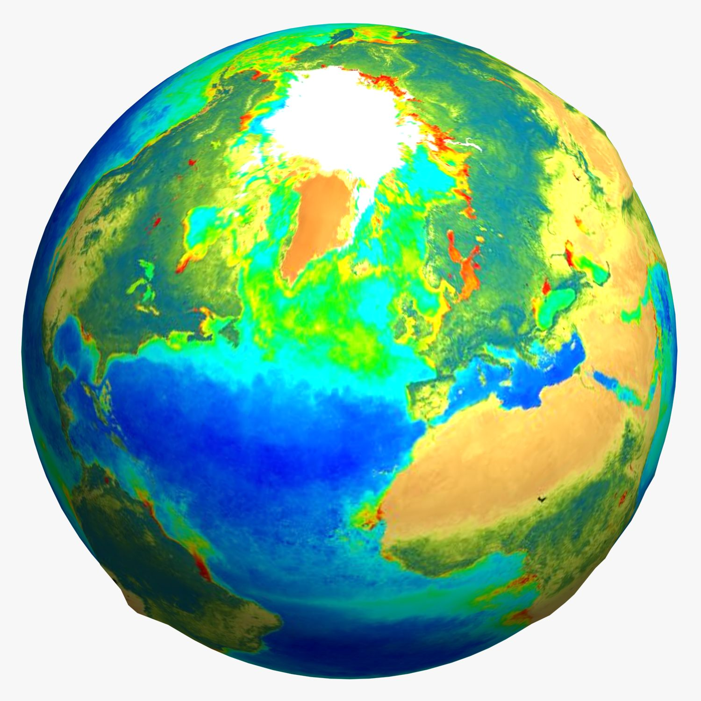

Biomes are the major regional groupings of plants and animals discernible at a global scale. Their distribution patterns are strongly correlated with regional climate patterns and identified according to the climax vegetation type.

However, a biome is composed not only of the climax vegetation, but also of associated successional communities, persistent subclimax communities, fauna, and soils.

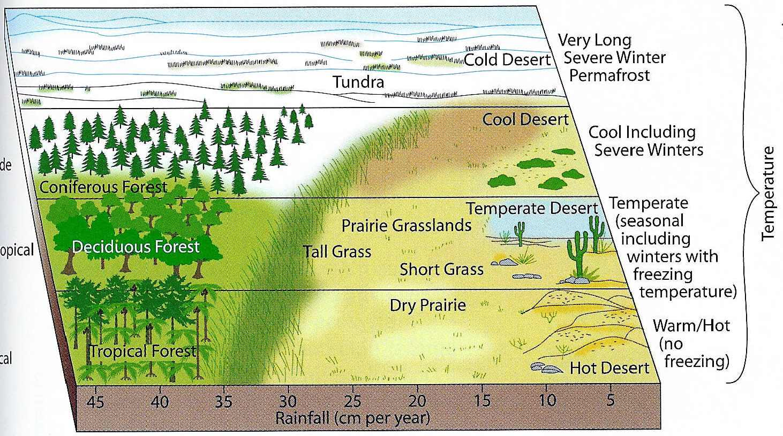
Polar
Mid-Latitude
Sub-Tropical
Tropical
Terrestrial Biomes Comparison

Biome | Water | Temperature | Soil | Plants | Animals
Desert
Chapparal
(scrub)
Tundra
Taiga
(coniferous forest)
Temperate Deciduous Forest
Grassland
Tropical rain forest
Swamp
Cave

Terrestrial Biomes Comparison ANSWERS

Biome | Water | Temperature | Soil | Plants | Animals
Desert | Almost none | hot or cold | poor | sparse - succulents (like cactus), sage brush | sparse - insects, arachnids, reptiles and birds (often nocturnal)
Chapparal (scrub) | dry summer, rainy winter | hot summer, cool winter | poor | shrubs, some woodland (like scrub oak) | drought and fire-adapted animals
Tundra | dry | cold | permafrost (frozen soil) | lichens and mosses | migrating animals
Taiga (coniferous forest) | adequate | cool year-round | poor, rocky soil | conifers | many mammals, birds, insects, arachnids, etc.
Temperate Deciduous Forest | adequate | cool season and warm season | fertile soil | deciduous trees | many mammals, birds, reptiles, insects, arachnids, etc.
Grassland | wet season, dry season | warm to hot (often with a cold season) | fertile soil | grasses (few or no trees) | many mammals, birds, insects, arachnids, etc.
Tropical rain forest | very wet | always warm | poor, thin soil | many plants | many animals
Swamp | very wet | warm | nutrient-rich soil | many plants | many animals
Cave (terrestrial) | variable | cool (and dark) | rocks | almost no plants | few animals

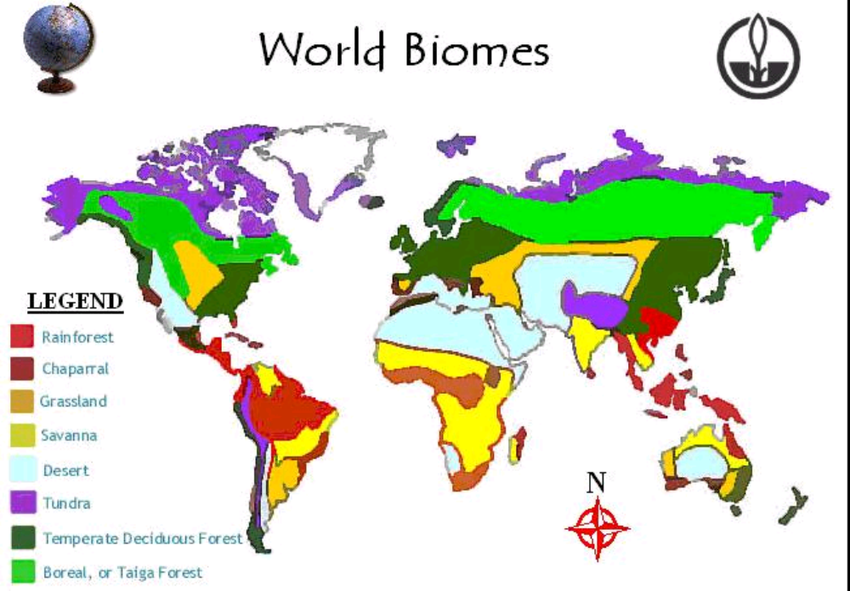
Biomes of the World
Biomes of North America

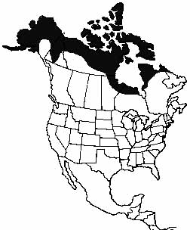
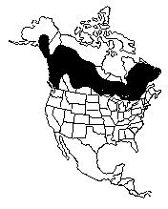
Tundra
Taiga
Biomes of North America
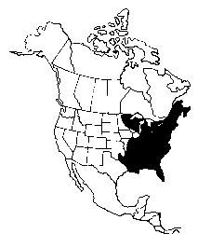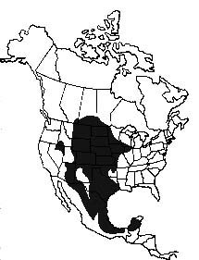
Temperate
Deciduous
Forest
Grasslands
Biomes of North America

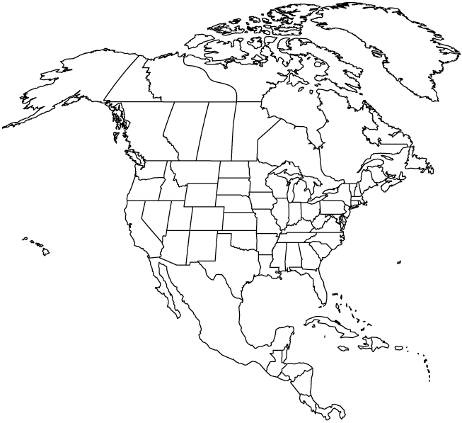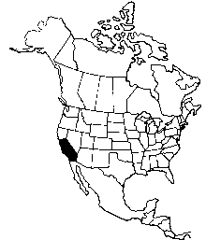
Desert
Chapparal
Biomes of North America
Tropical Rainforest
PLUS
Localized Biomes:
- swamps
- caves

Tropical Rainforests Fact Sheet

Rainforests cover 2% of the Earth's surface, or 6% of its land mass, yet they house over half the plant and animal species on Earth. They originally covered at least twice that area.
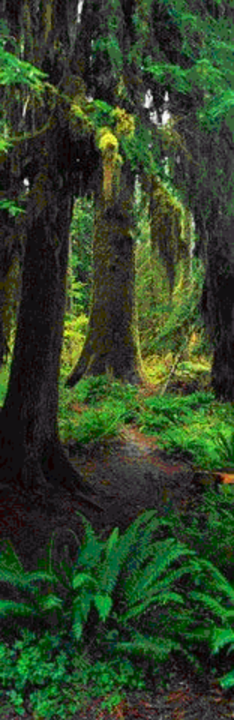
Tropical rainforests are defined primarily by two factors: location (in the tropics) and amount of rainfall they receive. Rainforests receive from 4 to 8 meters of rain a year -- 5 meters of rain falls on the rainforests of Borneo each year, five times as much as on the state of New York. The heavy vegetation blocks the rainfall, and water reaches the forest floor by rolling down branches and trunks or as a fine spray. Another distinctive characteristic is that rainforests have no "seasonality" -- no dry or cold season of slower growth. (Myers, Norman, The Primary Source)

Tropical rainforests are the Earth's oldest living ecosystems. Fossil records show that the forests of Southeast Asia have existed in more or less their present form for 70 to 100 million years. (Myers, Norman, The Primary Source) Tropical rainforests are the Earth's oldest living ecosystems.
Rainforests are being destroyed at a staggering rate. According to the National Academy of Science, at least 50 million acres a year are lost, an area the size of England, Wales and Scotland combined.

All the primary rainforests in India, Bangladesh, Sri Lanka and Haiti have been destroyed already. The Ivory Coast rainforests have been almost completely logged. The Philippines lost 55% of its forest between 1960 and 1985; Thailand lost 45% of its forest between 1961 and 1985.

Despite the small land area they cover, rainforests are home to about half of the 5 to 10 million plant and animal species on the globe. Rainforests also support 90,000 of the 250,000 identified plant species. Scientists estimate that there are at least 30,000 as yet undiscovered plants, most of which are rainforest species. (Myers, Norman, The Primary Source)

One fourth of the medicines available today owe their existence to plants. Seventy percent of the plants identified by the National Cancer Institute as useful in cancer treatment are found only in the rainforest. Drugs used to treat leukemia, Hodgkin's disease and other cancers come from rainforest plants, as do medicines for heart ailments, hypertension, arthritis and birth control. Yet fewer than 1% of tropical forest species have been thoroughly examined for their chemical compounds. (Myers, Norman, The Primary Source) A typical four square mile patch of rainforest contains as many as 1500 species of flowering plants

Many of the foods we eat today originated in rainforests: avocado, banana, black pepper, Brazilian nuts, cayenne pepper, cassava/manioc, cashews, chocolate/cocoa, cinnamon, cloves, coconut, coffee, cola, corn/maize, eggplant, fig, ginger, guava, herbal tea ingredients (hibiscus flowers, orange flowers and peel, lemon grass), jalapeño, lemon, orange, papaya, paprika, peanut, pineapple, rice, winter squash, sweet pepper, sugar, tomato, turmeric, vanilla, and Mexican yam. The wild strains still in the rainforests of many of these plants provide genetic materials essential to fortify our existing agricultural stock. Many other rainforest plants have great promise to become other staple foods. (Caufield, Catherine, In the Rainforest)

While it's true that rainforests produce vast amounts of oxygen through photosynthesis, they consume as much as they produce in the decay of organic matter. Rainforests do affect our atmosphere and climate, but not through supplying the world's oxygen. (Caufield, Catherine, In the Rainforest)

Rainforests play a critical role in the atmosphere in part because they hold vast reserves of carbon in their vegetation. When rainforests are burned, or the trees are cut and left to decay, the carbon is released into the atmosphere as carbon dioxide (CO2). This is the second largest factor contributing to the greenhouse effect. (Caufield, Catherine, In the Rainforest)

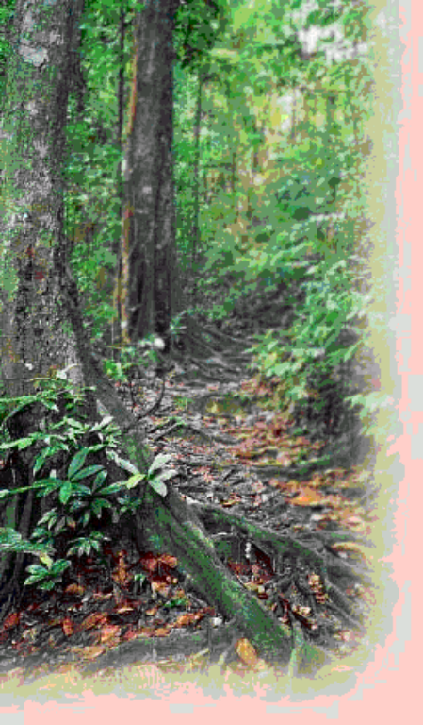
Four-fifths of the nutrients in the rainforests are in the vegetation. This means that the soils are nutrient-poor and become eroded and unproductive within a few years after the rainforest is cleared.

A typical four square mile patch of rainforest contains as many as 1500 species of flowering plants, 750 species of trees, 125 mammal species, 400 species of birds, 100 of reptiles, 60 of amphibians, and 150 different species of butterflies. In one study, one square meter of leaf litter, when analyzed, turned up 50 species of ants alone. (National Academy of Sciences.)

The tropics are the earth's richest natural reserves. One fifth of all the birds and plants on Earth evolved in the Amazon Basin. (Steinhart, Peter, National Wildlife Federation, Dec./Jan. 1984)

The uneven distribution of wealth and land is one major factor in the destruction of tropical forests. The World Bank estimates that of the 2.5 billion people now living in the tropics one billion exist in absolute poverty. (Raven, Peter H, Bulletin of Atomic Scientists, November 1984.)
Deserts Fact Sheet

Approximately one-third of the Earth's land surface is desert, arid land with meager rainfall that supports only sparse vegetation and a limited population of people and animals. Deserts--stark, sometimes mysterious worlds--have been portrayed as fascinating environments of adventure and exploration from narratives such as that of Lawrence of Arabia to movies such as "Dune." These arid regions are called deserts because they are dry. They may be hot, they may be cold. They may be regions of sand or vast areas of rocks and gravel peppered with occasional plants. But deserts are always dry.

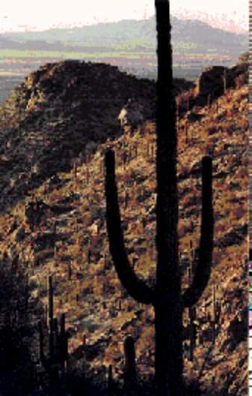
Deserts are natural laboratories in which to study the interactions of wind and sometimes water on the arid surfaces of planets. They contain valuable mineral deposits that were formed in the arid environment or that were exposed by erosion. Because deserts are dry, they are ideal places for human artifacts and fossils to be preserved. Deserts are also fragile environments. The misuse of these lands is a serious and growing problem in parts of our world.

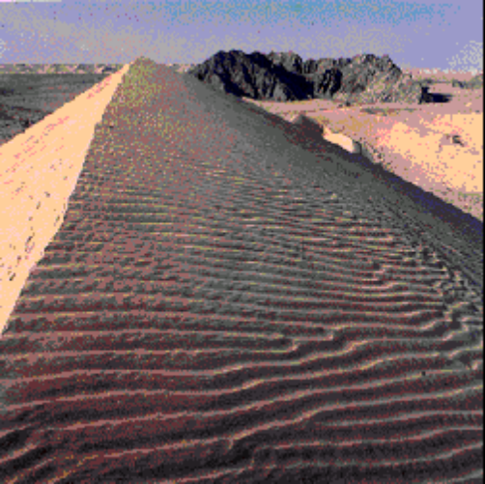
There are almost as many definitions of deserts and classification systems as there are deserts in the world. Most classifications rely on some combination of the number of days of rainfall, the total amount of annual rainfall, temperature, humidity, or other factors. In 1953, Peveril Meigs divided desert regions on Earth into three categories according to the amount of precipitation they received. In this now widely accepted system, extremely arid lands have at least 12 consecutive months without rainfall, arid lands have less than 250 millimeters of annual rainfall, and semiarid lands have a mean annual precipitation of between 250 and 500 millimeters. Arid and extremely arid lands are deserts, and semiarid grasslands generally are referred to as steppes.

Desert Features

Sand covers only about 20 percent of the Earth's deserts. Most of the sand is in sand sheets and sand seas--vast regions of undulating dunes resembling ocean waves "frozen" in an instant of time.
Nearly 50 percent of desert surfaces are plains where eolian deflation--removal of fine-grained material by the wind--has exposed loose gravels consisting predominantly of pebbles but with occasional cobbles.

The remaining surfaces of arid lands are composed of exposed bedrock outcrops, desert soils, and fluvial deposits including alluvial fans, playas, desert lakes, and oases. Bedrock outcrops commonly occur as small mountains surrounded by extensive erosional plains.

Soils

Soils that form in arid climates are predominantly mineral soils with low organic content. The repeated accumulation of water in some soils causes distinct salt layers to form. Calcium carbonate precipitated from solution may cement sand and gravel into hard layers called "calcrete" that form layers up to 50 meters thick.

Plants

Most desert plants are drought- or salt-tolerant. Some store water in their leaves, roots, and stems. Other desert plants have long tap roots that penetrate the water table, anchor the soil, and control erosion. The stems and leaves of some plants lower the surface velocity of sand-carrying winds and protect the ground from erosion.

Deserts typically have a plant cover that is sparse but enormously diverse. The Sonoran Desert of the American Southwest has the most complex desert vegetation on Earth. The giant saguaro cacti provide nests for desert birds and serve as "trees" of the desert. Saguaro grow slowly but may live 200 years. When 9 years old, they are about 15 centimeters high. After about 75 years, the cacti are tall and develop their first branches. When fully grown, saguaro are 15 meters tall and weigh as much as 10 tons. They dot the Sonoran and reinforce the general impression of deserts as cacti-rich land.

Water

Rain does fall occasionally in deserts, and desert storms are often violent. A record 44 millimeters of rain once fell within 3 hours in the Sahara. Large Saharan storms may deliver up to 1 millimeter per minute. Normally dry stream channels, called arroyos or wadis, can quickly fill after heavy rains, and flash floods make these channels dangerous. More people drown in deserts than die of thirst.
Though little rain falls in deserts, deserts receive runoff from ephemeral, or short-lived, streams fed by rain and snow from adjacent highlands. These streams fill the channel with a slurry of mud and commonly transport considerable quantities of sediment for a day or two. Although most deserts are in basins with closed, or interior drainage, a few deserts are crossed by 'exotic' rivers that derive their water from outside the desert. Such rivers infiltrate soils and evaporate large amounts of water on their journeys through the deserts, but their volumes are such that they maintain their continuity.
Elements of Survival

What do you believe is most important to survival?

- food
- water
- shelter
- love

Decide which one you feel is the most correct response. Go to the appropriate corner that identifies your choice. Brainstorm and write down why you believe you are right.

When we discuss quality of life and standard of living, what we deem important here in Canada may not be important in other parts of the world!





LOVE

FOOD

WATER

SHELTER
Quality of Life Revisited

- Quality of life concerns the standard of living and the non-material things that people desire to improve the way they live.

- Quality of life is affected by material standards of living, but it also includes environmental, social and political factors

- A clean environment, human rights, political freedom, and freedom of opportunity are only a few examples of non-material elements of life that most people desire.

How do resource development, food, and water play key roles in determining quality of life?

“If we all lived like people do in Nigeria, we would have plenty of energy, the water wouldn’t be polluted, the air would be clean. We’d all be poor, but we would be able to sustain our population at much greater numbers than we do now. It’s the impact the population has on the planet that is worrisome, not the actual numbers.”

Katherine MacDonald
Action on Population and Development, 2000

Resource Profile

Our quality of life is directly linked to the quality of our environment. We desire a high quality of life and therefore we must desire a high quality of environment…..but do we hold or environment with such a high regard?

You will investigate various resource harvesting or extracting methods used around the global village. Based on your research, you will decide if the methods used are environmentally sound or not. You will also offer suggestions to improve upon our current situation. You will present your findings in a report, poster, PowerPoint presentation, or other creative means.

Possible Topics
- Clear Cutting the Amazon Rainforest
- The Exporting of Canadian Fresh Water
- Open Pit Mining in Canada (or Africa)
- Drag Net Fishing Practices
- Diamond Extraction in Northern Canada
- Or any other resource harvesting method approved by your teacher!!

Information to Include
- Identify the resource you have selected
- Identify the country you are harvesting your resource in (include a MAP)
- Identify how the resource is obtained & processed
- Identify how the resource is used
- Evaluate the economic, social and ecological impacts of harvesting the resource in the method under investigation
- Describe the future outlook of this resource
- As a conclusion, discuss in a paragraph or two, the interdependence of ecology and economics

Level 1  50-59% | Level 2  60-69% | Level 3  70-79% | Level 4  80-100% | Level  Assigned
Report  demonstrated  limited knowledge of facts, terms, concepts and theories. | Report  demonstrated some knowledge of facts, terms, concepts and theories. | Report demonstrated considerable knowledge of facts, terms, concepts and theories. | Report  demonstrated thorough knowledge of facts, terms, concepts and theories.
Report has not been organized and research was not conducted in an effective manner. | Report has been organized and research was conducted in a somewhat effective manner. | Report has been organized and research was conducted in an effective manner. | Report has been organized and research was conducted in a highly effective manner.

